**Practice : AWK**

**Create dataset : emp10.txt**

7369,SMITH,CLERK,800,20,17-DEC-80

7499,ALLEN,SALESMAN,1600,30,20-FEB-81

7521,WARD,SALESMAN,1250,30,22-FEB-81

7566,JONES,MANAGER,2975,20,02-APR-81

7654,MARTIN,SALESMAN,1250,30,28-SEP-81

7698,BLAKE,MANAGER,2850,30,01-MAY-81

7782,CLARK,MANAGER,2450,10,09-JUN-81

7788,SCOTT,ANALYST,3000,20,19-APR-87

7839,KING,PRESIDENT,5000,10,17-NOV-81

7844,TURNER,SALESMAN,1500,30,08-SEP-81

7876,ADAMS,CLERK,1100,20,23-MAY-87

7900,JAMES,CLERK,950,30,03-DEC-81

7902,FORD,ANALYST,3000,20,03-DEC-81

7934,MILLER,CLERK,1300,10,23-JAN-82

1. Display all employees working as MANAGER

2. Display all employees taking salary of 5000  
  
3. Display only 1st and 3rd field

4. Display only 2nd field.

5. Print “hello world” change “world” to “john” and print using “awk”

6. Convert to upper case for all records.

Output :   
7369 SMITH CLERK 800 20 17-DEC-80  
  
7. Changing only 2nd field to upper  
SMITH

8. Count the Number of employees works as CLERK, MANAGER and PRESIDENT.  
(Note : Write individual statements for each job)

9. Write awk program to store the string “Hello, World !!!” to a file named “/home/oracle/Desktop/a.txt”

10. Write awk program to translate the string “Hello, World !!!” to upper case.

11. Using While LOOP, write a script prints the roll number, name, and average marks acquired by each student.

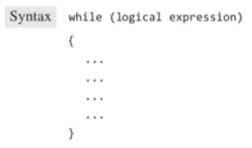

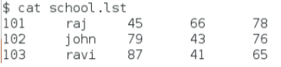

Output :



12. Using DO WHILE, Create a script that prints the roll number, name, and average marks acquired by each student.

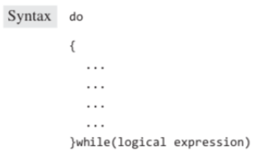

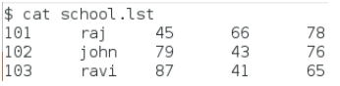

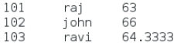

13. Using FOR LOOP , Print the roll number, name, and the average marks acquired by each student.

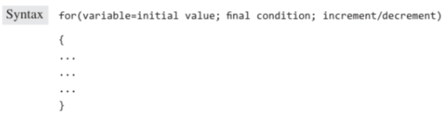

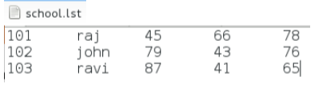

OUTPUT :

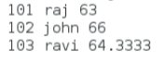

14. Display all the records not starting from any character in the range A to W to Customer’s Name in the file bank.lst.

15. Display all the records having A as the first character in the second field and cur as the first three characters in the fifth field of the file bank.lst.

OUTPUT :



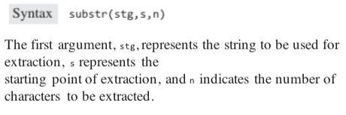

16. Display all the records having “09” as the last two digits in the fourth field of the file bank.lst.

Output :

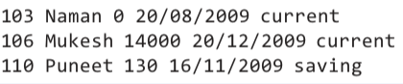

17. Count the number of customers with current account.



18. Display all the records where the second field is more than four characters long from bank.lst

OUTPUT:

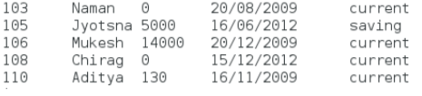

19. Create a script removes the first four lines from the file bank.lst and stores the rest of the lines in the file passed as the command line argument. To a new file called “backup_bank.lst”.

20. Create a script finds the maximum and minimum balance in the bank.lst file.

OUTPUT :

